CR-10162 (see IMAPS Help Request 20180108122548) - Automate the process of updating the DDOU PLC rates data in Costpoint

Date Submitted: 02/19/2018

**Input Data File Preparation**

IMPORTANT: Prior to preparing the data for processing, it is crucial that the system operator inspects the Excel data supplied by the customer to ensure that the data format conforms with the database design of the PLC_RATES interface. Any deviation from the interface’s data design will result in interface execution failure. For more detailed information about the data requirements, please read the document *Analysis & Requirements.docx*, which is provided with the source code in ClearCase repository.

The user performs this task to transform the original customer-supplied Excel file(s) into a predetermined form and format used by the PLC_RATES interface. The following procedure shows how to convert the user-supplied Excel data files to a single, tab-delimited text file to be used by the SQL Server bulk copy or bcp utility.

In this example, the customer has supplied two Excel files, one for Costpoint project DDOU.ICAB and one for project DDOU.NPUB.

Step 1: Save the Excel files as ASCII text files. This example uses the Excel file for Costpoint project DDOU.ICAB.

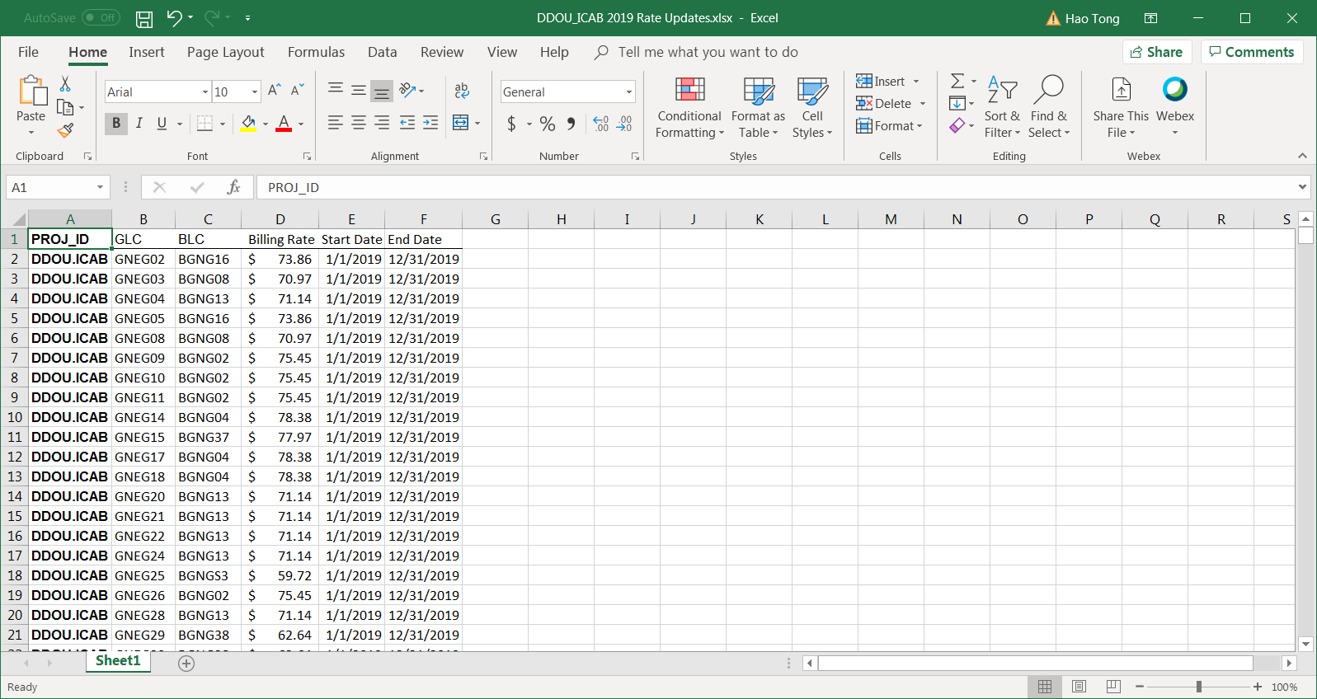

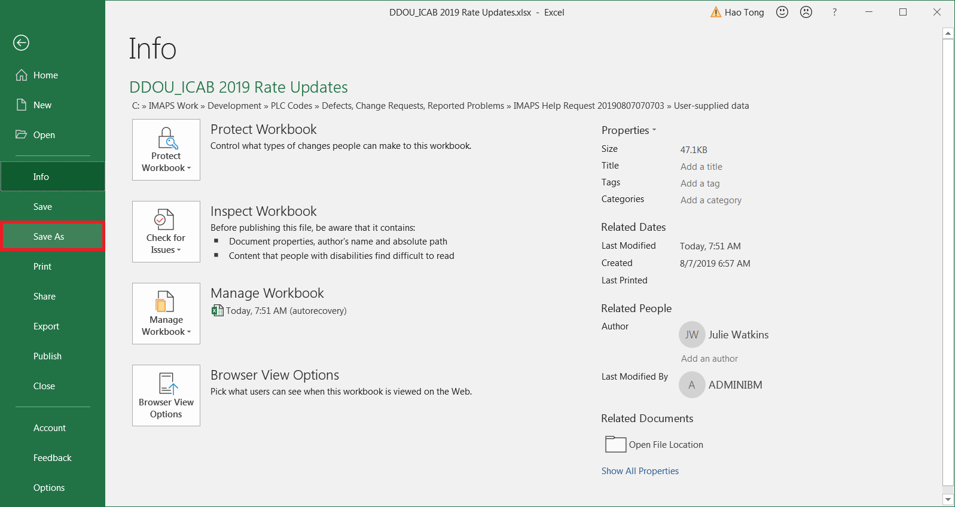

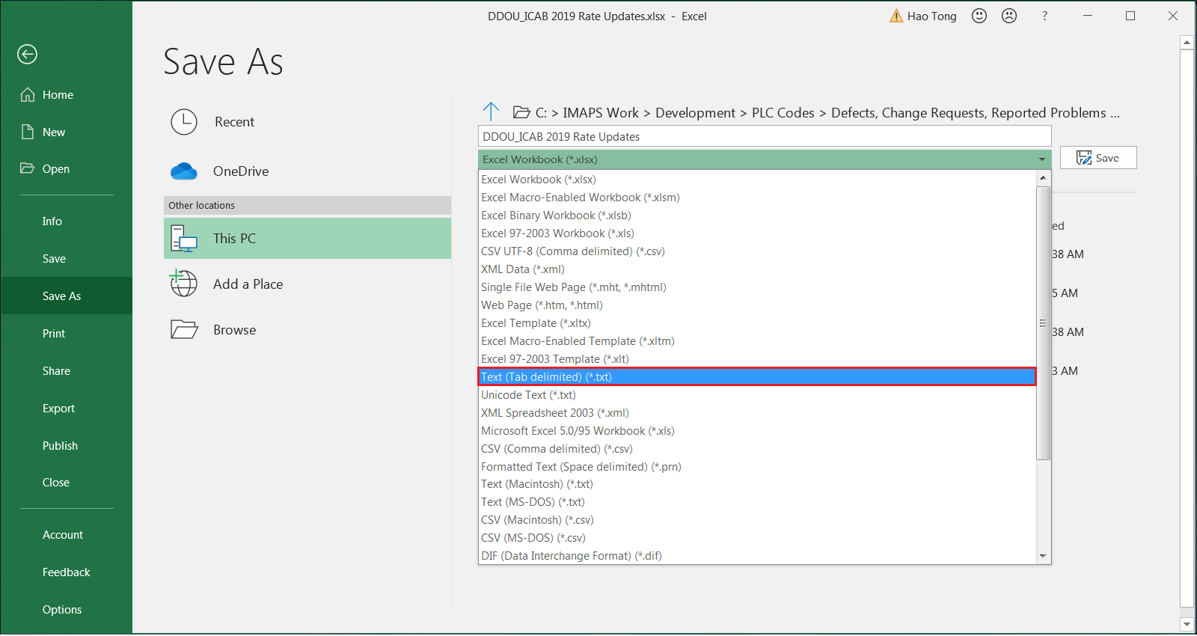

Name the new text file using the Excel file’s name and the file name format

DDOU MMM YYYY Rate Updates.txt

where MMM and YYYY are the current month and year, respectively, as shown in this example, DDOU AUG 2019 Rate Updates.txt. Failure to name text file in the format accepted by the PLC_RATES interface will cause fatal interface execution errors.

IMPORTANT: If the names of the customer-supplied Excel files are considered reasonably cumbersome, rename them in the format

DDOU MMM YYYY Rate Updates.xlsx

where MMM and YYYY are the current month and year, respectively, as well.

Save the Excel file as a text (tab-delimited) .TXT file. Select option Text (Tab delimited) (*.txt).

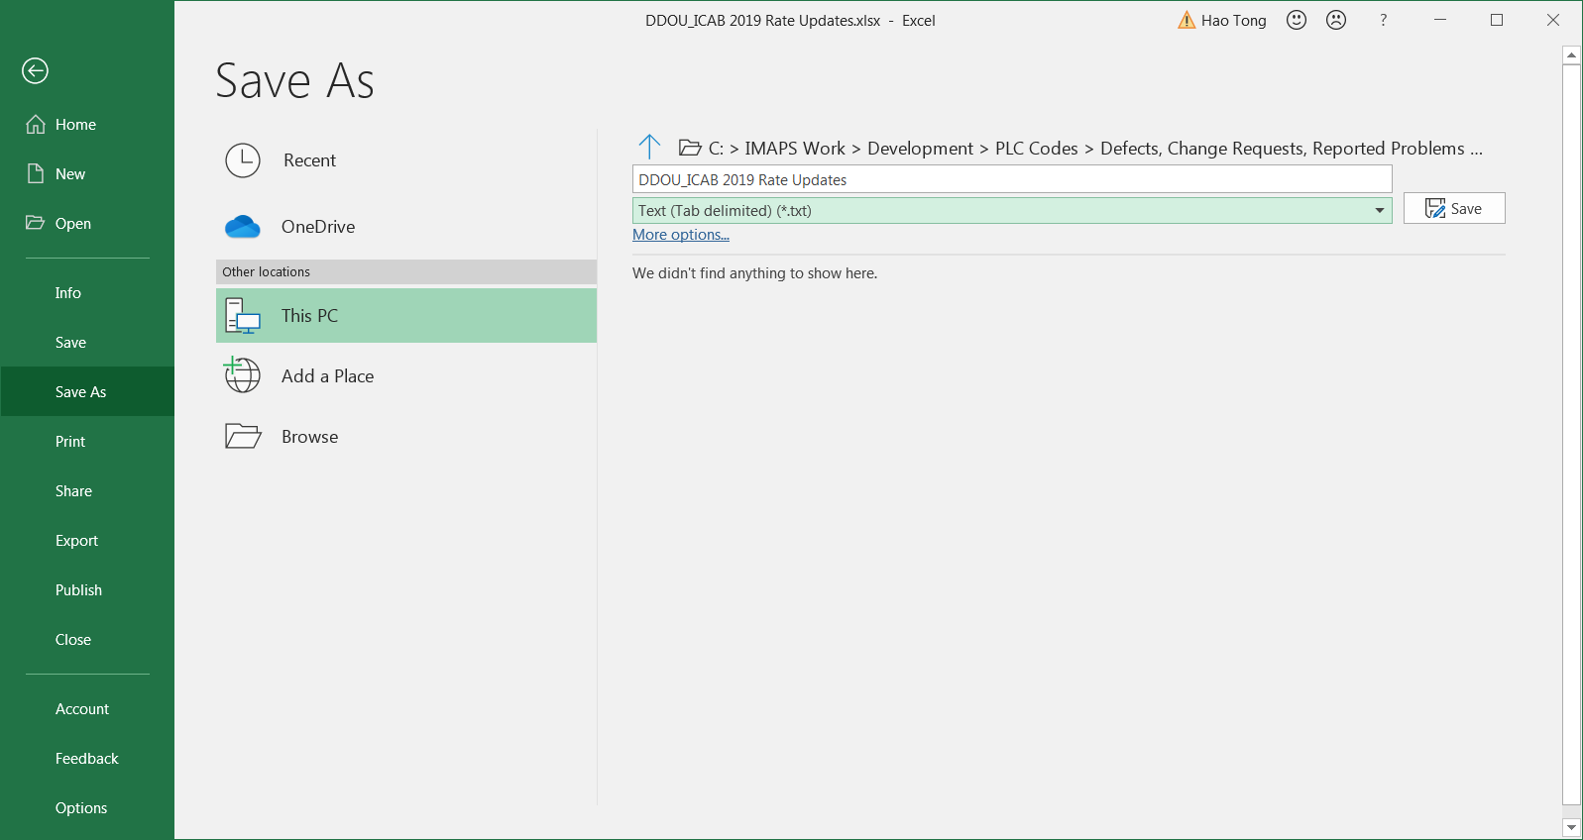

Using the same procedure, save the Excel file for Costpoint project DDOU.NPUB as ASCII text file. The results are shown below.

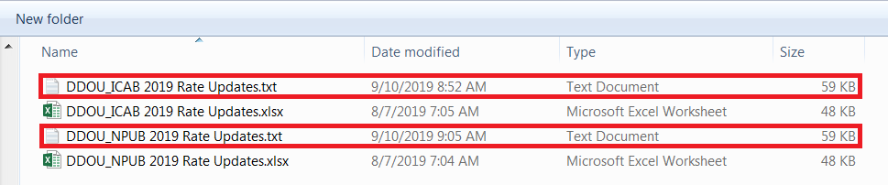

Step 2: Merge the new text files into one file. The goal is to have one single text file destined for the PLC_RATE execution environment. In other words, there must be at most one customer-supplied text data file submitted for processing.

Append the contents of DDOU_NPUB 2019 Rate Updates.txt to DDOU_ICAB 2019 Rate Updates.txt. Save the expanded file DDOU_ICAB 2019 Rate Updates.txt as a new file, DDOU AUG 2019 Rate Updates.txt, using the current month in the new file’s name.

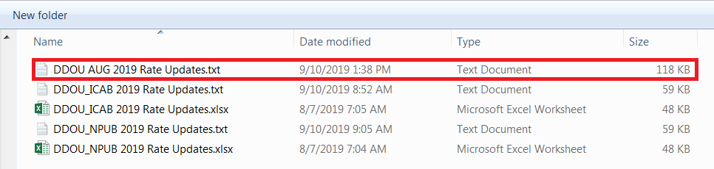

Edit the new file DDOU AUG 2019 Rate Updates.txt. Remove the two column header lines from the new file.

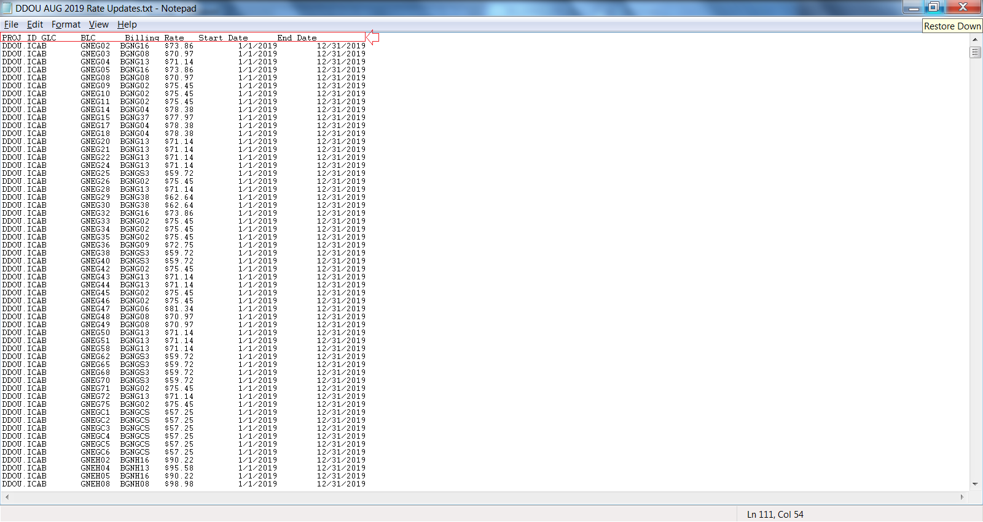

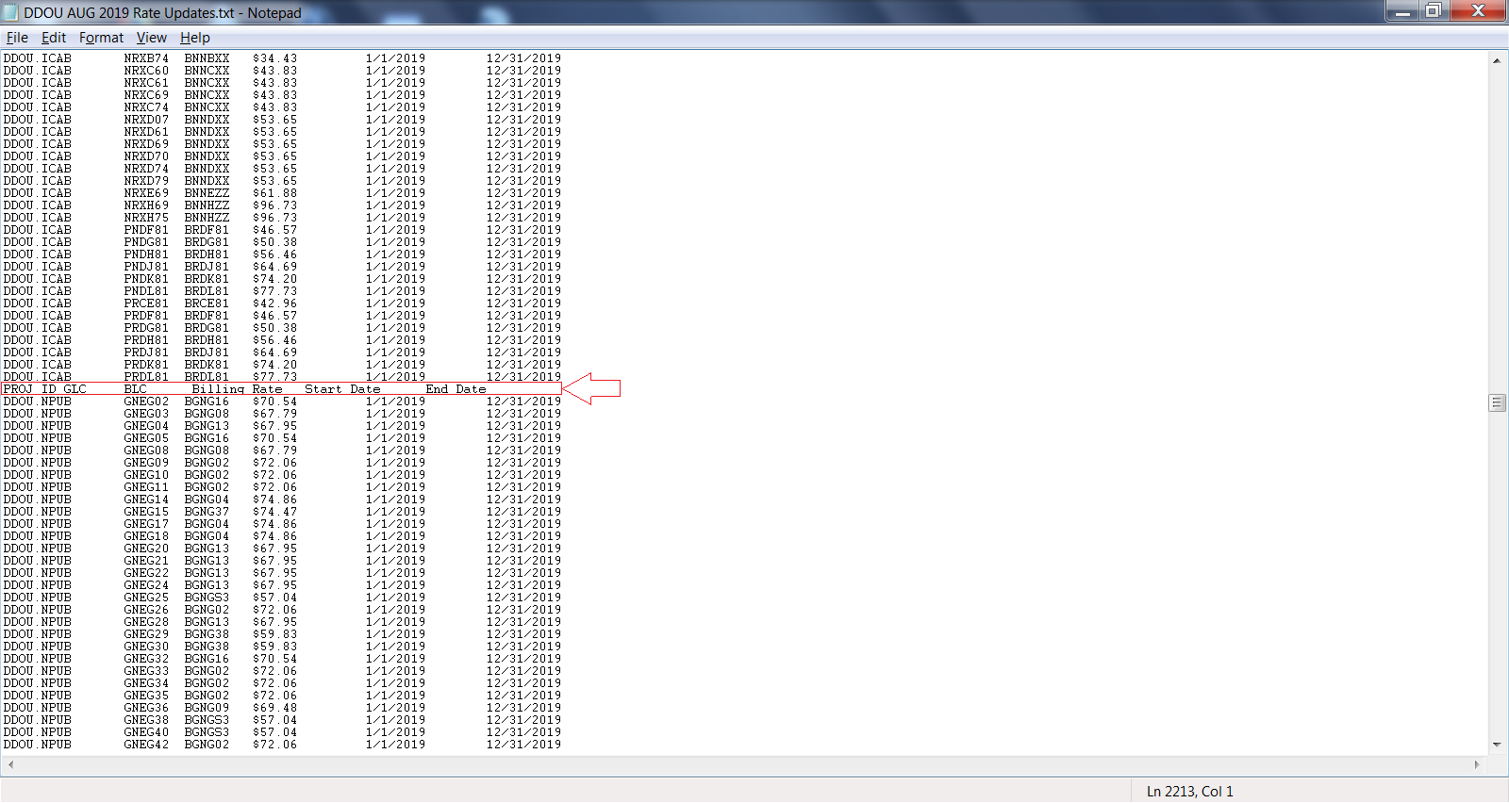

Remove the blank lines resulting from the removal of the two column header lines.

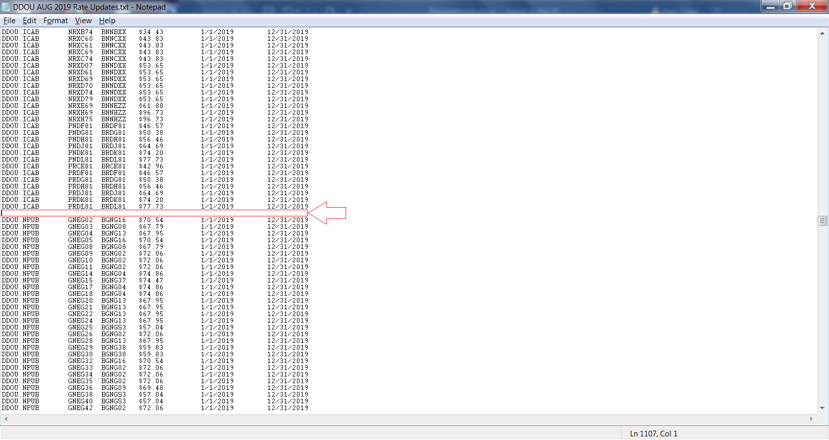

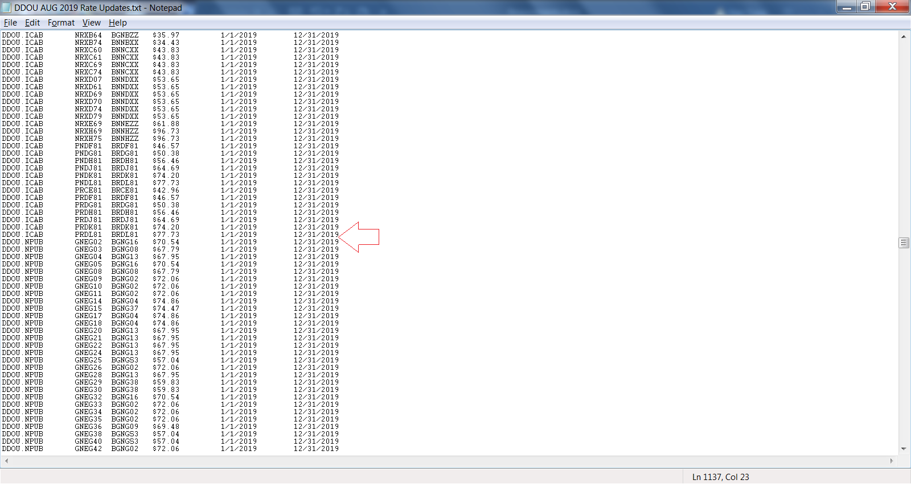

Step 3: If the customer-supplied data come in more than one Excel file (typically, one for Costpoint project DDOU_ICAB and one for DDOU_NPUB), then the data must be placed in a single file using a single sheet and only one column header. If the customer supplies the data in one Excel file and in more than one sheet, then the data must be placed in a single sheet. This requirement is due to restriction in DOS file renaming operation which does not allow multiple files to be renamed to one particular file name. In summary, there must be at most one customer-supplied Excel data file submitted for processing.

Append the contents of DDOU_NPUB 2019 Rate Updates.xlsx to DDOU_ICAB 2019 Rate Updates.xlsx. Save the expanded file DDOU_ICAB 2019 Rate Updates.xlsx as a new file, DDOU AUG 2019 Rate Updates.xlsx, using the current month in the new file’s name.

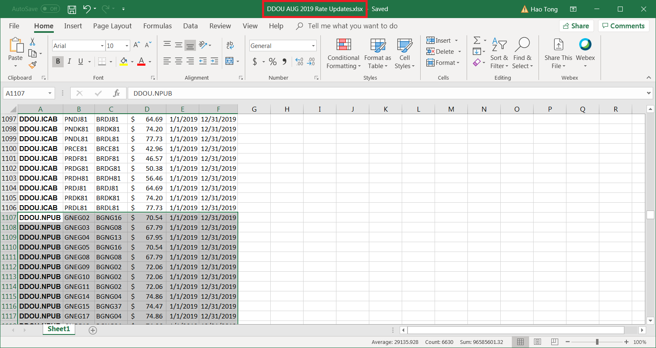

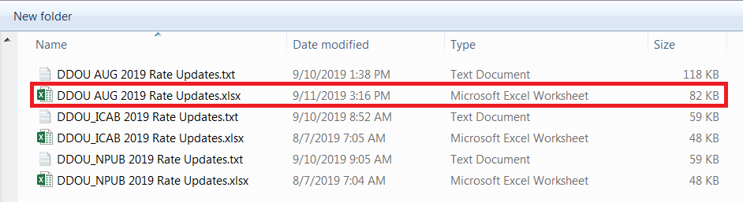

Step 4: Place the DDOU PLC rate update text file and the two customer-supplied Excel files in the INBOX folder on the server that provides the PLC_RATES interface’s execution environment.

Map the network drive of the server that provides the PLC_RATES interface’s execution environment.

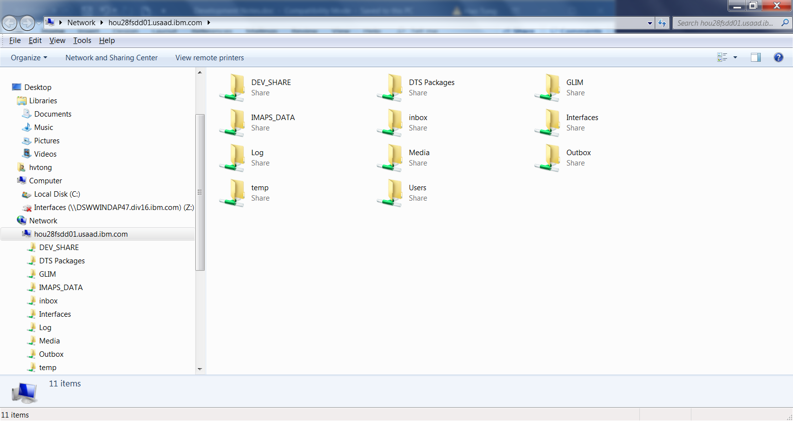

Navigate to the target folder \\hou28fsdd01.usaad.ibm.com\IMAPS_DATA\inbox\PLC_RATES. The exact folder to place the DDOU rate update text file can be learned by this query: SELECT * FROM dbo.XX_PROCESSING_PARAMETERS WHERE INTERFACE_NAME_CD = 'PLC_RATES'.

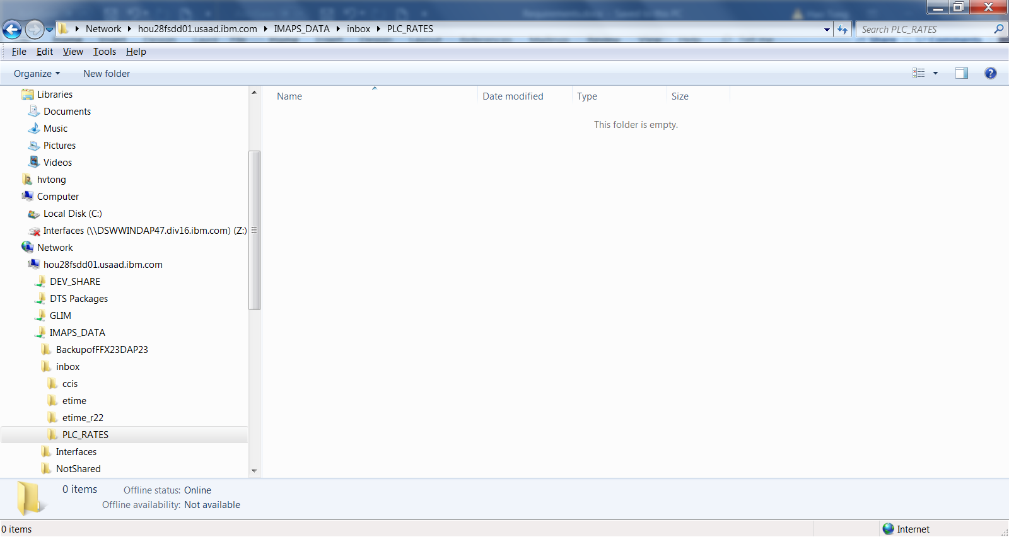

Drag the files DDOU AUG 2019 Rate Updates.txt, DDOU_ICAB 2019 Rate Updates.xlsx and DDOU_NPUB 2019 Rate Updates.xlsx from your computer and drop them in the network drive’s folder D:\IMAPS_DATA\inbox\PLC_RATES.

Both the newly created text file and the original customer-supplied Excel files will be archived by the PLC_RATES interface.

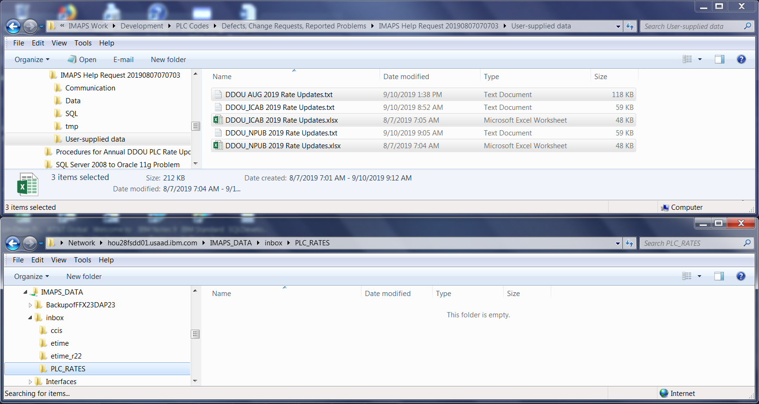

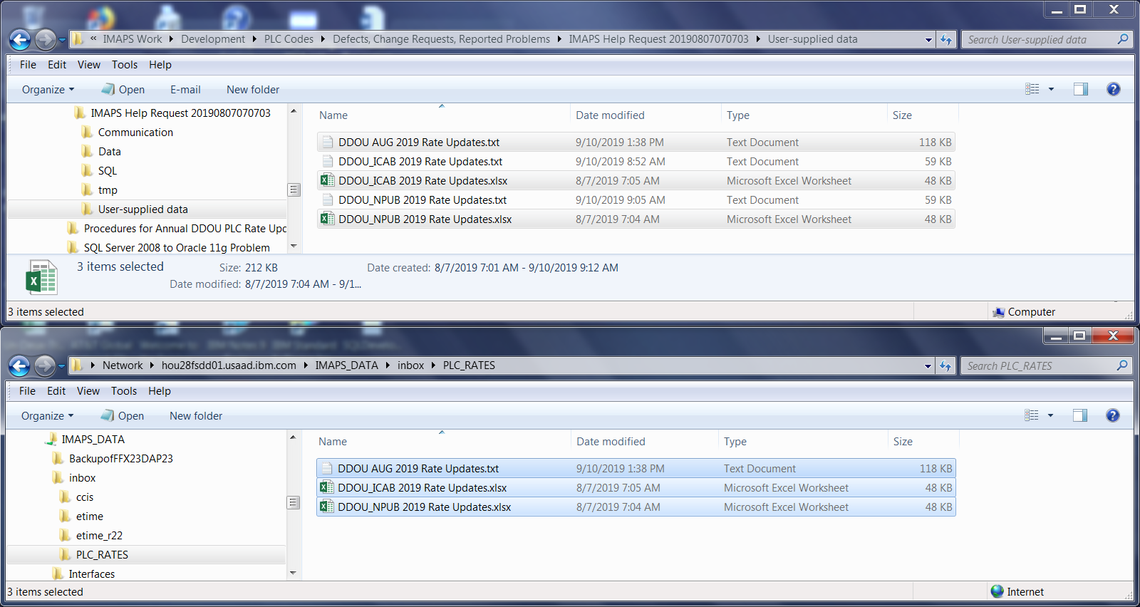

The file copy’s results are shown below in the PLC_RATES interface’s execution environment.

